**L. VARSHINI**

**192372045**

**CSA1618 DWDM**

**EXPERIMENT-28**

**PREDICTION OF CATEGORICAL DATA USING SMO ALGORTIHM THROUGH WEKA**

**AIM:**

To create prediction of categorical data using SMO Algorithm through weka tool.

**PROCEDURE:**

1. Download and install WEKA.
2. Open WEKA and Choose "Explorer" from the main menu.
3. Under Preprocess, Click on the open file button and select the dataset. Ensure that your dataset contains categorical (nominal) attributes.
4. Go to the Classify tab.
5. Click Choose → Expand the functions section → Select SMO (Sequential Minimal Optimization).
6. Click on SMO to open parameter settings : Kernel Type (K): Default is PolyKernel (Polynomial Kernel), change it to RBFKernel (Radial Basis Function, good for complex data), C value (C): Regularization parameter (default is 1.0), Epsilon (E): Controls the stopping criterion (default 1.0E-12).
7. Click OK to save settings.

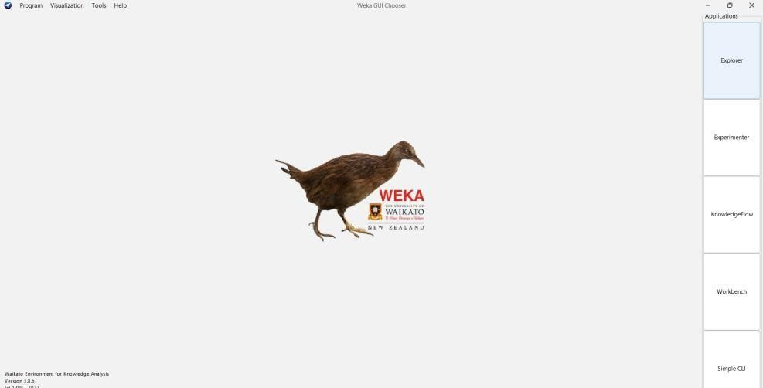

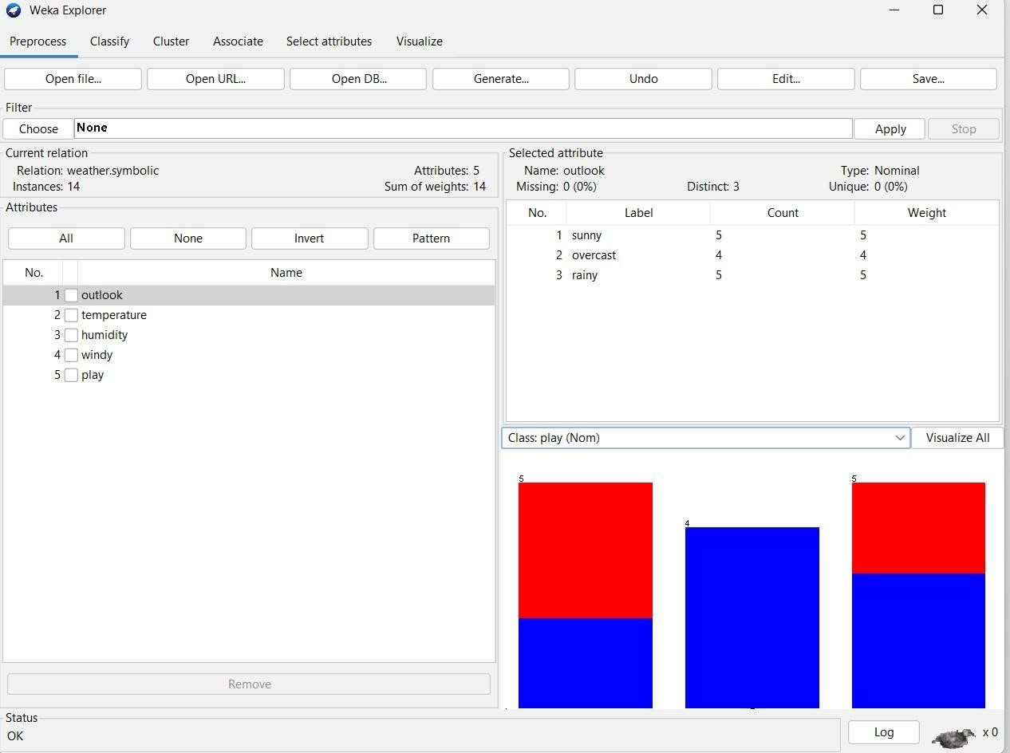

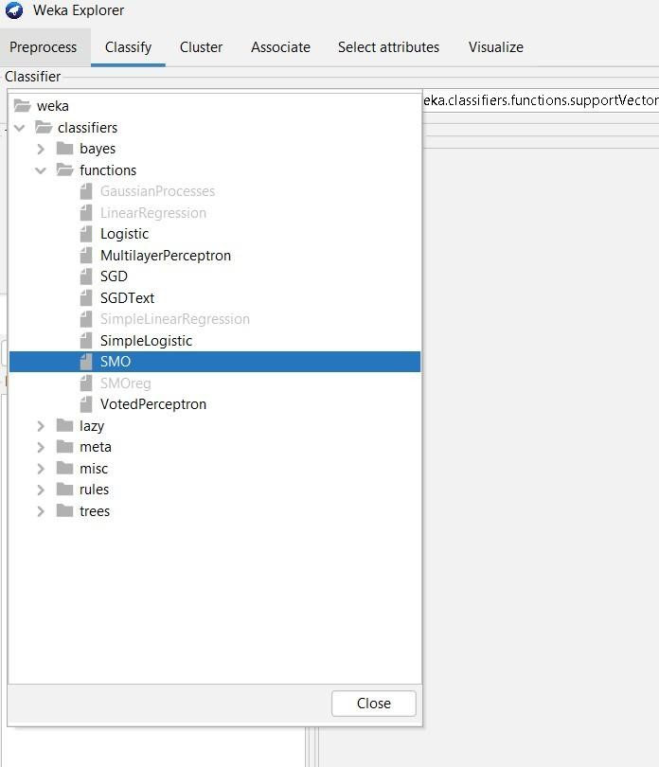

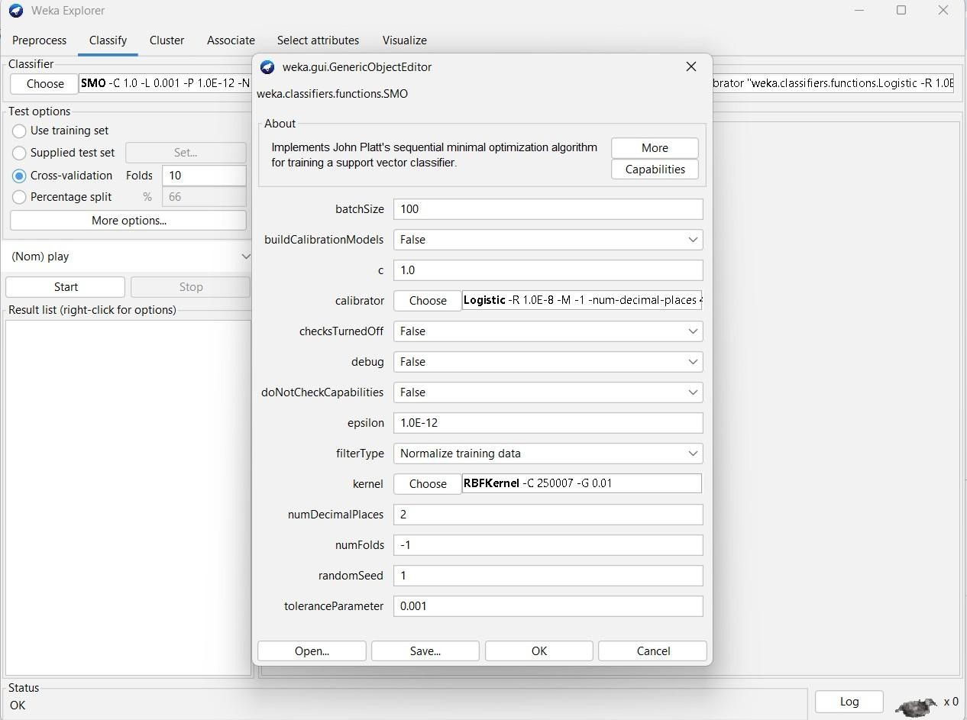

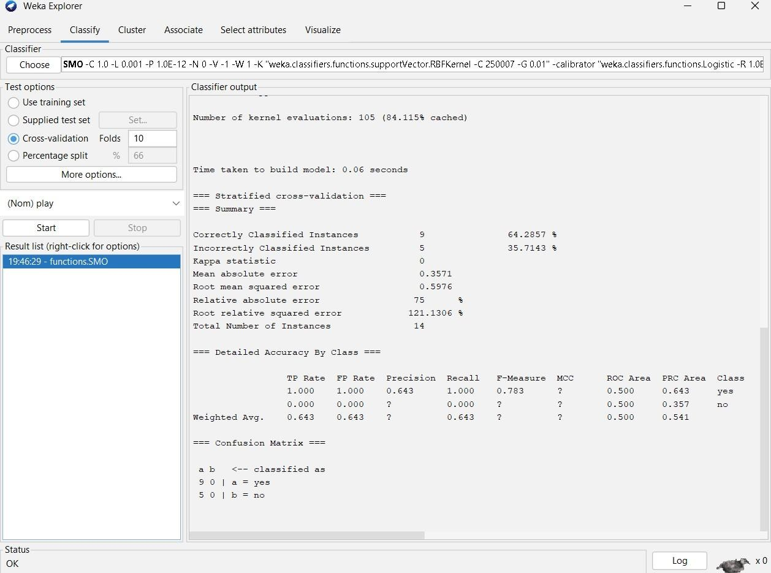

**OBSERVATION:**

=== Classifier model (full training set) ===

SMO

Kernel used:

RBF Kernel: K(x,y) = exp(-0.01*(x-y)^2)

Classifier for classes: yes, no

BinarySMO

1 * <0 0 1 0 1 0 0 0 > * X]

* 1 * <1 0 0 0 1 0 1 0 > * X]

+ 1 * <1 0 0 0 1 0 0 1 > * X]

+ 1 * <1 0 0 1 0 0 0 0 > * X]

* 1 * <0 0 1 0 1 0 0 1 > * X]
* 0.3383 * <0 0 1 0 0 1 1 1 > * X]

+ 1 * <1 0 0 1 0 0 0 1 > * X]

* 1 * <1 0 0 0 0 1 1 1 > * X]
* 0.6617 * <0 1 0 0 1 0 0 0 > * X]
* 1 * <0 1 0 1 0 0 0 1 > * X]

+ 1 * <0 0 1 0 0 1 1 0 > * X]

* 0.9805

**Number of support vectors: 11**

**Number of kernel evaluations: 105 (84.115% cached)**

Time taken to build model: 0.06 seconds

=== Stratified cross-validation ===

=== Summary ===

Correctly Classified Instances 9 64.2857 %

Incorrectly Classified Instances 5 35.7143 %

Kappa statistic 0

Mean absolute error 0.3571

Root mean squared error 0.5976

Relative absolute error 75 %

Root relative squared error 121.1306 % Total

Number of Instances 14

=== Detailed Accuracy By Class ===

TP Rate FP Rate Precision Recall F-Measure MCC ROC Area PRC Area

1.000 1.000 0.643 1.000 0.783 ? 0.500 0.643 yes

0.000 0.000 ? 0.000 ? ? 0.500 0.357 no

Wt Avg. 0.643 0.643 ? 0.643 ? ? 0.500 0.541

=== Confusion Matrix ===

a b <-- classified as

9 0 | a = yes

5 0 | b = no

**RESULT:**

Thus, the observations and evaluations done on the dataset are analyzed. The implementation of Sequential Minimal Optimization (SMO) has been successfully visualized.